Enrollment Pack
Enrolment form and Language Literacy and Numeracy (LLN) Assessment
Quality Training in Construction
2017

The participant is required on enrolment to fill in the enrolment kit which contains the learning, literacy and numeracy assessment.

From the assessment the most suitable qualification is chosen for the participant based on the students existing educational attainment and capabilities.

This ensures that the participants of LJS Constructions Pty Ltd trading as Quality Training in Construction receive the training, assessments and support services that meet their individual needs.

Instructions to the Participant:

The participant has 30 minutes to complete the task.

The participant can ask for help reading or understanding the task.

The participant can use a calculator.

Task 1: Please fill in the enrollment form

Task 2: Read the sign and answer the 4 questions relating to the sign.

Task 3: Please calculate the equations.

Task 4: Please give your opinion on how you would solve the problem.

Task 5: Read and fill in the declaration form signing and dating on completion.

The enrollment pack is given to the Trainer/Assessor to mark.

The results are then mapped with the ACSF table to determine if support services are required.

If the Trainer/Assessor should determine that the support services are required then the Trainer/Assessor shall contact the Participant to discuss the findings and make arrangements of the type and structure of the Participant support required.

Task 1:

Enrolment Form

PERSONAL DETAILS
Surname: |  |  |  |  |  |  |  |  |  |  |  |  |  | First Name:
Address:
Postal Address:
(if different from above)
Phone: |  |  |  |  |  |  |  |  |  |  |  |  |  |  | Email:
USI: |  |  |  |  |  |  |  |  |  |  |  |  |  |  | Date of Birth:
Gender: |  |  |  |  |  | - Male | - Female |  |  |  |  |  | Country of Birth:
Are you an |  | - Australian citizen |  |  |  |  |  | - Permanent resident |  |  |  |  |  |  |  |  |  | - New Zealand Passport holder |  |  |  |  |  |  |  |  |  |  | - Work Visa holder
Are you of Aboriginal or Torres Strait Islander origin? |  |  |  |  |  |  |  |  |  | - Yes, Aboriginal |  |  |  |  |  |  |  |  |  |  | - Yes, Torres Strait Islander |  |  |  |  |  |  |  |  |  |  |  | - Neither
What language do you mainly speak at home? |  |  |  |  |  |  |  |  |  |  |  | - English |  |  |  |  |  |  |  |  | - Other :
How well do you speak English? |  |  |  |  |  |  |  |  |  |  | - Very Well |  |  |  |  |  |  |  |  |  | - Well |  |  |  |  | - Not Well |  |  |  |  |  | - Not At All
Are you enrolled in the same qualification with another RTO, different program or funding arrangement? |  |  |  |  |  |  |  |  |  |  |  |  |  |  |  |  |  |  |  |  |  |  |  |  |  |  |  |  |  |  | - Yes |  |  |  |  | - No
Course: |  |  |  |  |  |  |  |  |  |  |  |  |  |  |  |  |  |  |  | - Apprenticeship/Traineeship |  |  |  |  |  |  |  |  |  |  |  |  |  |  | - RPL

EMPLOYER
Business Name: |  |  |  |  |  |  |  |  |  |  |  |  |  |  |  | Contact Person:
Address: |  |  |  |  |  |  |  |  |  |  |  |  |  |  |  |  | State: |  |  |  |  |  |  |  |  |  |  | Post Code:
Phone: |  |  |  |  |  |  |  |  |  |  |  |  |  |  |  |  | Fax:
Mobile: |  |  |  |  |  |  |  |  |  |  |  |  |  |  |  |  | Email Address:
STATISTICAL DETAILS
This information is used for statistical purposes only. Please state details, or tick relevant box.
Are you still attending secondary schooling?
Name of School you are attending:
What is your highest completed school level?
In what year did you complete that school level?
Since leaving school have you completed any qualifications?
Qualification Name:
Current Employment Status:  - Full-time  - Part-time  - Self employed |  |  |  |  |  |  | - Employer  - Unpaid family  - Unemployed

Do you consider yourself to have a permanent and significant disability? |  |  |  |  | - Yes | - No
- Visual / Sight  - Intellectual  - Hearing | - Chronic Illness  - Physical  - Other - please specify:
STATISTICAL DETAILS (cont.)
Of the following categories, which BEST describes your main reason for undertaking this course?
- To get a job  - To get into another course of study  - To develop my existing business  - To start my own business  - To try for a different career |  | - To get a better job or promotion  - It was a requirement of my job  - I wanted extra skills for my job  - For personal interest or self-development  - Other - please specify: ___________________________
I have received the Participant Handbook containing all of the following information:
- Nationally Recognised Training Offered  - Our Service Commitment  - Access and Equity Policy  - Expectations of Participants  - Participant Support  - Refund Policy  - Competency Based Training and Assessment  - Credit Transfer  - Recognition of Prior Learning |  |  | - Access to Participant Records  - Release of contact details and information  - Change of Personal Details  - Complaints and Appeals  - Results  - Reissuance of Certificate/Statement of Attainments  - Course Evaluation  - Relevant Legislation – to be complied with  - Fees
TERMS AND CONDITIONS
- Course work progression - participants are required to notify Quality Training in Construction as soon as it is practical of any event or any difficulties impacting the progress of their training and completion of their qualification, and if necessary apply for an extension.
- There is no charge for reassessment.
- Should you withdraw from the course ten (10) working days before the course commencement all fees paid in advance will be refunded.
- If you decide you no longer wish to participate in the course after this point then fees paid that have been paid will be forfeited and the balance of fees owing.
You can negotiate a deferred start date as long as it is within six (6) months of withdrawing.
- Quality Training in Construction does not collect fees of more than $1000 in advance or hold more than $1500 in advance once the training commences.
- Partial or full refunds will be considered after the commencement of the course under exceptional circumstance such as long-term illness. Quality Training in Construction reserves the right to request reasonable proof of such circumstances. No refund will be granted for training and assessment services already provided.
- Should Quality Training in Construction cancel the training agreement, a fair and reasonable refund will be granted, if fees are paid in advance. Charges will be incurred for services provided prior to cancellation.
- No refund is available should you remain enrolled in the course and do not progress. Should you decide not to continue with your course you need to notify us of your intention to withdraw or defer.
- Full payment of fees is required prior of the issuance of the Statement of Attainment or Certificate.
Participants who successfully complete the requirements prior to the planned completion date can receive their Statement of Attainment/Certificate on completion, as long as all course fees are paid in full.

Task 2:
Please read the sign and answer 4 questions relating to the sign.
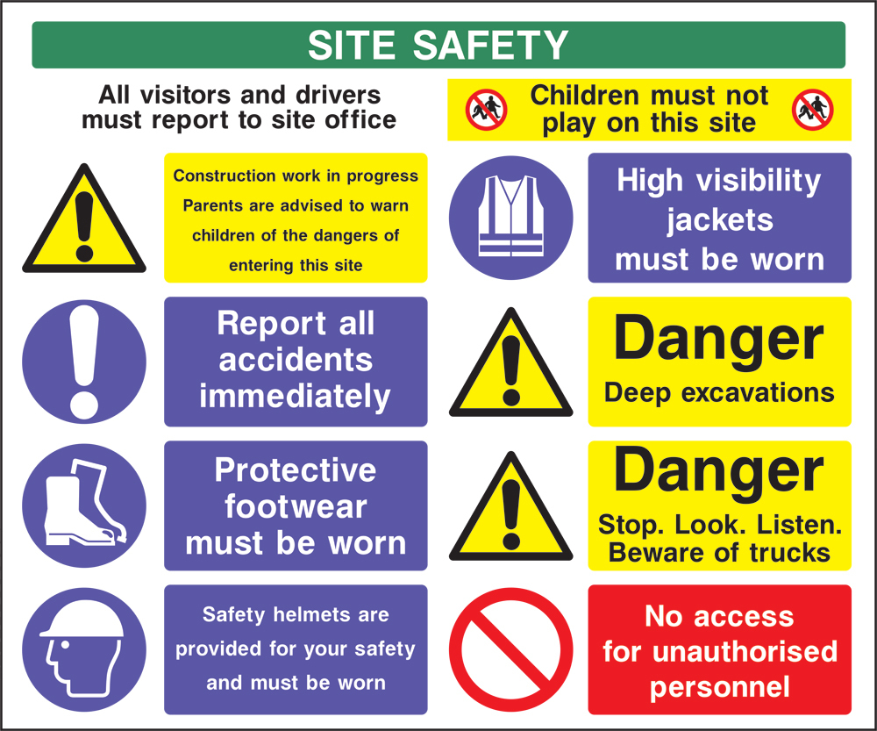

Q1: When do I report accidents?
_________________________________________________________________________
Q2: Why are the excavations dangerous?
_________________________________________________________________________
Q3: Are children allowed to play on the site?
_________________________________________________________________________
Q4: Who should report to the site office?
_________________________________________________________________________

Task 3:
From the diagrams below please calculate the following:
Please show all workings:
a. Convert
650mm into metres = ___________________
50m into millimetres = __________________
b. Perimeter:

2.0m

2.0m 2.0m

2.0m
Perimeter = __________________
c. Area

1.8m

15.0m
Area = ___________________

d. Volume:
Depth .1m
.4m

.5m
Volume = ____________________

e. If a cement mixer can be filled using 18 shovels of sand and the composition of mortar is 6 sand, 1 cement and 1 lime how much lime and cement would I need to put into the mixer.

f. There is a post hole which needs to be filled with concrete. The dimensions are 1.3m in depth and with a radius of .250m. Please calculate how much concrete you would need to order with a 5% added extra for waste.

Task 4

Please give your opinion and verbally discuss with the trainer before writing how you would solve the following dilemma.

There is a cement mixer on a concrete slab which is 1.2m up off the ground. How are you going to safely bring the mixer down onto the ground?

Task 5:

Credit Transfer
You may be eligible for a Credit Transfer if you have previously undertaken training through a Registered Training Organisation. Credit Transfer may be granted for one or more units. Three (3) major factors need to be considered:
- How current the Qualification/Statement of Attainment is
- Mapping to the current training and
- If the training was undertaken with a Registered Training Organisation.

If you think you may be eligible for a Credit Transfer you will need to provide the following:
- The original Statement of Attainment and/or Certificate for your Trainer to sight
- A copy of the Statement of Attainment and/or Certificate
- Or a certified copy of your signed Statement of Attainment and/or Certificate by a Justice of the Peace (JP)
- There is no charge for Credit Transfer

All applications for Credit Transfer will need to be verified with the issuing RTO to ensure its validity. In order to do this the Student will need to complete a “Release of Information form”. This form will be sent to the issuing RTO to gain confirmation that they issued the qualification/statement of attainment, accompanied by a copy of your qualification or statement of attainment.

Do you wish to apply for Credit Transfer? | - Yes | - No

Recognition of Prior Learning (RPL)
RPL is the process of formal recognition for skills and knowledge gained through previous learning such as:
- Life experiences
- Previous formal learning
- Employment
- Recreational or personal interests
You may be eligible for RPL for part or all of your intended study, based on your previous experiences and learning. For more information regarding RPL and how to apply, please discuss this with your Trainer.
Where the credit transfer and recognition of prior learning results of competency are 80% or more, the RTO must discuss with the participant and employer the choice of selecting a higher qualification or to continue on with the enrolled qualification. If the decision is made to continue on with the qualification, then it must be documented and evidence must be retained and filed in the participants file

Do you wish to apply for Recognition of Prior Learning? | - Yes | - No

Task 6:
Declaration:
I have read the Participant Handbook and agree to the conditions |  |  |  | € Yes € No
I understand that I have an obligation to pay the required training fees |  |  |  | € Yes € No
I do not wish to apply for a fee waiver |  |  |  | € Yes € No
I declare that I give permission for Quality Training in Construction to disclose my contact details to ASQA if requested for quality assurance purposes |  |  |  | € Yes € No
I give permission for Quality Training in Construction to publish my photograph for promotional material |  |  |  | € Yes € No
I acknowledge that I am enrolled with LJS Constructions Pty Ltd trading as Quality Training in Construction |  |  |  | € Yes € No
I have been informed of any subcontracting arrangements by another RTO to deliver  € Qualification € Units of competency |  |  |  | € Yes € No
I have received information regarding the assessment process |  |  |  | € Yes € No
I have completed the LLN (Language, Literacy and Numeracy) section of enrolment form |  |  |  | € Yes € No
I declare that the information above is true and correct |  |  |  | € Yes € No
Signature: |  | Date:
A certified copy of Photo ID has been provided or the original sighted.
NB: Proof of ID is required. Enrolments must provide certified (by Justice of the Peace) copy of Photo ID via the post or in person. Certificates will only be issued when acceptable certified ID is provided. A fax copy is not acceptable. You can find a list of JP’s in your state by Googling “Justice of the Peace List”.

Quality Training in Construction
Trainers/Assessors
Marking Guide

Instructions to the Trainer/Assessor:
- Please mark the Tasks from 1 through to 5 from the sample answers in the trainer/Assessors marking guide.
- Please fill in the ACSF Table and document the findings.
- From the table please identify if the qualification is appropriate for the Participant.
- Is a meeting required with the Participant?
- If yes, Please document your findings and the recommendations in which you feel are appropriate for the participant.
- Fill in a draft copy of the Participant Support kit of your recommendations approach your Training Manager to address these concern.
- Contact the Participant to make an appointment to discuss the findings and to establish a plan to support the Participant.

Task 2:
Please read the sign and answer 4 questions relating to the sign.

Q1: When do I report accidents?
A Report all accidents immediately
Q2: Why are the excavations dangerous?
A The excavation is deep
Q3: Are children allowed to play on the site?
A Children must not play on this site
Q4: Who should report to the site office?
A All visitors and drivers

Task 3:
From the diagrams below please calculate the following:
Please show all workings:
a. Convert
650mm into metres = 0.65m
50m into millimetres = 50 000mm
b.

2.0m

2.0m 2.0m

2.0m
Perimeter = 2.0m + 2.0m + 2.0m + 2.0m = 8m
c.

1.8m

15.0m
Area = 1.8m x 15.0m = 27m²
d.
Depth .1m
.4m

.5m
Volume = 0.4m x .5m x 0.1m = 0.02m³

e. If a cement mixer can be filled using 18 shovels of sand and the composition of mortar is 6 sand, 1 cement and 1 lime how much lime and cement would I need to put into the mixer.

A = 3 Cement and 3 Lime

f. There is a post hole which needs to be filled with concrete. The dimensions are 1.3m in depth and with a radius of .250m. Please calculate how much concrete you would need to order.

A = Formula Pir²H
Pi x .250² x 1.3m
= 0.255m³
= 0 .255m³ of concrete x 5%
= 0.267m³

Task 4

Please give your opinion on how you would solve the following problem. Verbally discuss with the trainer before writing how you would solve the following dilemma.

There is a cement mixer on a concrete slab which is 1.2m up off the ground. How are you going to safely bring the mixer down onto the ground?

Task 1: | ACSF Level | Indicator | Correct
Fills in the enrollment form  (Writing) | 1 | - Entire form may be incomplete  - Personal details completed  - Approximate spelling  - Vocabulary limited to basic words
 | 2 | - Completes the whole form with accuracy.  - Meaning is clear some spelling mistakes.  - Vocabulary is sufficient.
 | 3 | - Accurately completes entire form.  - Spelling consistent and reasonably accurate.  - Vocabulary specific and relevant to the task and setting.
Task 2: and Task 6:
Read the sign and answer the questions  (Reading) | 1 | - Reads and responds to basic workplace information.  - Reads and responds to basic workplace instructions.  - Reads and responds to basic workplace signs and symbols.
 | 2 | - Reads and responds to simple workplace information.  - Read and respond to simple informal workplace text.  - Reads and responds to simple workplace procedures.
 | 3 | - Reads and responds to routine workplace information.  - Reads and responds to standard operating procedures.  - Reads and responds to visual and graphic text.
Task 3
From diagrams and information please calculate the following  (Numeracy) | 1 | - Uses whole numbers up to 1000 for work.  - Locates, compares and uses highly familiar measurements for work. +, -, 21/5/12
 | 2 | - Identifies and uses whole numbers and simple fractions, decimals and % for work.  - Identifies measurements and estimates familiar quantities for work.  - Uses basic functions and a calculator.  - +,-, x, /, meters (m)
 | 3 | - Calculates with whole no. and familiar fractions, decimals and % for work.  - Estimate, measures and calculates with routine metric measurements for work.  - Uses common functions of a scientific calculator for work.  - Decimal placing , length, perimeter, area, volume, converts mm into m or m into mm.
 | 4 | - Apply an expanding range of mathematical calculations for work.  - Estimates, calculates measurements for work.  - Applies relevant ratio, proportions and calculates decimals.
 | 5 | - (V=Pir²h)  - Estimates and accurately measures calculations of quantities including complex area and volumes using measurements formulae
Task 4
Please give your opinion on how you would solve the following problem. Verbally discuss with the trainer before writing how you would solve the following dilemma.  (Learning, oral communication) | 1 | - Identifies strategies to respond to basic workplace problems engages in basic spoken exchanges of work.
 | 2 | - Use strategies to plan simple workplace tasks participate in simple spoken interactions at work.
 | 3 | - Uses strategies to respond to routine workplace problems.  - Interacts effectively with others at work.  - Use oral communication skills to participate in the workplace.

Office use only

The Training/Assessor is to document the findings of the assessment.

Meeting with Apprentice required (please circle) Yes / No

If answer is yes, the following recommendations are made.

- Determine the level of the qualification most suitable for the participant:

____________________________________________________________________________________

- Determine the need for additional support for the participant:
________________________________________________________________________________________________________________________________________________________________________________________________________________________________________________________________________________________________________________________________________________

- Identify how adjustments can be made to the:

Learning Strategies:
________________________________________________________________________________________________________________________________________________________________________________________________________________________________________________________________________________________________________________________________________________________________________________________________________________________________________________________________________________________________________________________
Materials:

____________________________________________________________________________________________________________________________________________________________________________________________________________________________________________________________________________________________________________________________________________________________________________________________________________________________________

Training and Assessment Strategy:
________________________________________________________________________________________________________________________________________________________________________________________________________________________________________________________________________________________________________________________________________________________________________________________________________________________________________________________________________________________________________________________

Trainer/Assessors Signature

Date ___/___/___

