Quality Training in Construction (QTiC) commenced the CPC20120 Certificate II in Construction - High School students on 26th October 2021, at Alfred Deakin High School, with 23 students from Melrose High School, Mt Stromlo High School and Alfred Deakin High School.

The Certificate II in Construction was a program that was funded by the ACT Education Directorate whilst The Rotary Club donated funds to the school program to cover the cost of personal protective clothing and boots for the students.

10 students from Melrose High School, 7 from Mt Stromlo High School and 6 from Alfred Deakin High School were selected by their respective schools. Two students from Melrose High School withdrew from the program prior to commencement whilst the other student from Alfred Deakin High School withdrew to go back to normal classes in the first week.

This course was very challenging indeed. The course commenced during a Covid 19 shutdown period so the students commenced using an online schooling system. Due to the Covid 19 restrictions Quality training in Construction staff had to teach from within the Alfred Deakin High School.

Once Term 4 at the school began and the students could actually attend the school, the rain came and did not want to stop. Normally the students would have a lot of practice with the trowel prior to building an actual pizza oven structure but not this time.

The pizza oven was made and completed in time for the students graduation which was absolutely amazing considering the odds were stacked against them. There were plans for many more items to be constructed but the weather and time for Covid shutdown restrictions; it was just not possible.

The deck had to be rescheduled so was constructed during the January 2022 school holidays in between more bouts of rain. Ten students came throughout this week to work with the carpenter and the trainers.

After completing the 3 initial theoretical subjects, we commenced the Project design subject. Quality Training in Construction discussed the project design requirements with Alfred Deakin High School advising their specifications for the project, a Pizza Oven and a timber deck for the Youth Centre, replica of a quiet seating area. We commenced planning and organising the project. Students planned, designed and organised when the construction activities take place for the project. This is immensely useful for using all the calculations that they are learning about.

In the first few weeks many challenges were overcome, for example class behaviour and completing assessments. We focussed on listening skills and involving all students in class discussions of the project. We also focussed on behaviour and teaching our most disruptive students to be responsible for their own learning and behaviour. Some of these students became aware of how “their” disruptive behaviour affected the individual learning of other students, who did want to learn, and gave respect to those students, so they were able to complete their studies.

19 students completed the course and were awarded a CPC20112 Certificate II in Construction.

1 was cancelled for poor behaviour which was terribly sad as only a couple of units were remaining top be completed.

**Attendance**

There were 20 students that commenced the program. Student attendance was high considering it was affected by Covid 19 and serious rainfall however attendance averaged out at 91.94%.

Of 20 students, attendance is as follows;

* 3 students had 100% attendance,
* 5 students over 97%;
* 6 students over 90%,
* 5 students have more than 85% attendance,
* 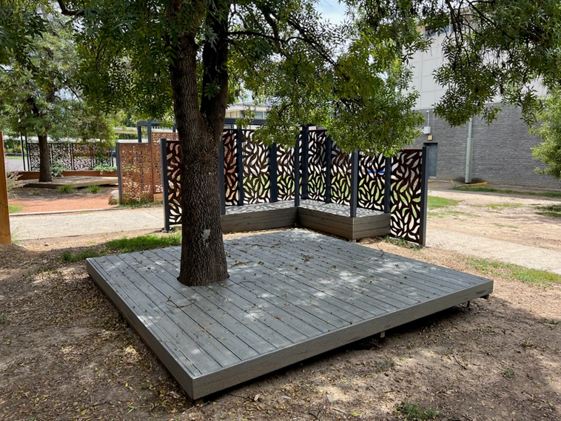1 was 58%.

